Step 1: Understand and Define the Problem (Analyse)
The goal is to design a combinational logic circuit that aperates an alarm when:
- The car ignition is ON
- Either the passenger or the driver seats are occuoied
- The corresponding seatbelt is not fastened
This means:
- If the driver is in the seat and the seatbelt is not fastened
- If the passeneger is in the seat and the seatbelt is not fastened
- If the car is on

Step 2: Organise and Describe the Data
Data Symbol | Type | Description | Active Logic
DRIV | INPUT | Driver seat occupied | 1 or HIGH
PASS | INPUT | Passeneger seat occupied | 1 or HIGH
IGN | INPUT | Ignition switch is ON | 1 or HIGH
BELTD | INPUT | Driver seat belt fastened | 1 or HIGH
BELTP | INPUT | Passenger seat belt fastened | 1 or HIGH
ALARM | OUTPUT | Car alarm activiated | 0 or LOW

Step 3: Plan the Solution (Design the Algorithm)
3.1 Algorithm (in plain English)
- Monitor ignition status: IGN must be HIGH
- Check if driver is stated and drivers belt is not fastened
  - DRIV = 1 AND BELTD = 0
- Check if passenger is seated and passengers belt is not fastened
  - PASS = 1 AND BELTP = 0
- If either condition above is TRUE and IGN = 1, the ALARM activates (LOW or 0)
- Otherwise, alarm remains HIGH or 1 (off)
3.2 Truth Table
DRIV | PASS | BELTD | BELTP | IGN | ALARM
0 | 0 | 0 | 0 | 1 | 1
0 | 0 | 0 | 1 | 1 | 1
0 | 0 | 1 | 0 | 1 | 1
0 | 0 | 1 | 1 | 1 | 1
0 | 1 | 0 | 0 | 1 | 1
0 | 1 | 0 | 1 | 1 | 1
0 | 1 | 1 | 0 | 1 | 1
0 | 1 | 1 | 1 | 1 | 1
1 | 0 | 0 | 0 | 1 | 0
1 | 0 | 0 | 1 | 1 | 0
1 | 0 | 1 | 0 | 1 | 1
1 | 0 | 1 | 1 | 1 | 1
1 | 1 | 0 | 0 | 1 | 0
1 | 1 | 0 | 1 | 1 | 0
1 | 1 | 1 | 0 | 1 | 0
1 | 1 | 1 | 1 | 1 | 1

3.3 Boolean Expressions (SOP)
DRIV | PASS | BELTD | BELTP | IGN | ALARM
1 | 0 | 0 | 0 | 1 | 0
1 | 0 | 0 | 1 | 1 | 0
1 | 1 | 0 | 0 | 1 | 0
1 | 1 | 0 | 1 | 1 | 0
1 | 1 | 1 | 0 | 1 | 0

- DRIV, $\overline{PASS}$, $\overline{BELTD}$, $\overline{BELTP}$, IGN
- DRIV, $\overline{PASS}$, $\overline{BELTD}$, BELTP, IGN
- DRIV, PASS, $\overline{BELTD}$, $\overline{BELTP}$, IGN
- DRIV, PASS, $\overline{BELTD}$, BELTP, IGN
- DRIV, PASS, BELTD, $\overline{BELTP}$, IGN

ALARM = DRIV, $\overline{PASS}$, $\overline{BELTD}$, $\overline{BELTP}$, IGN + DRIV, $\overline{PASS}$, $\overline{BELTD}$, BELTP, IGN + DRIV, PASS, $\overline{BELTD}$, $\overline{BELTP}$, IGN + DRIV, PASS, $\overline{BELTD}$, BELTP, IGN + DRIV, PASS, BELTD, $\overline{BELTP}$, IGN

3.4 Flowchart

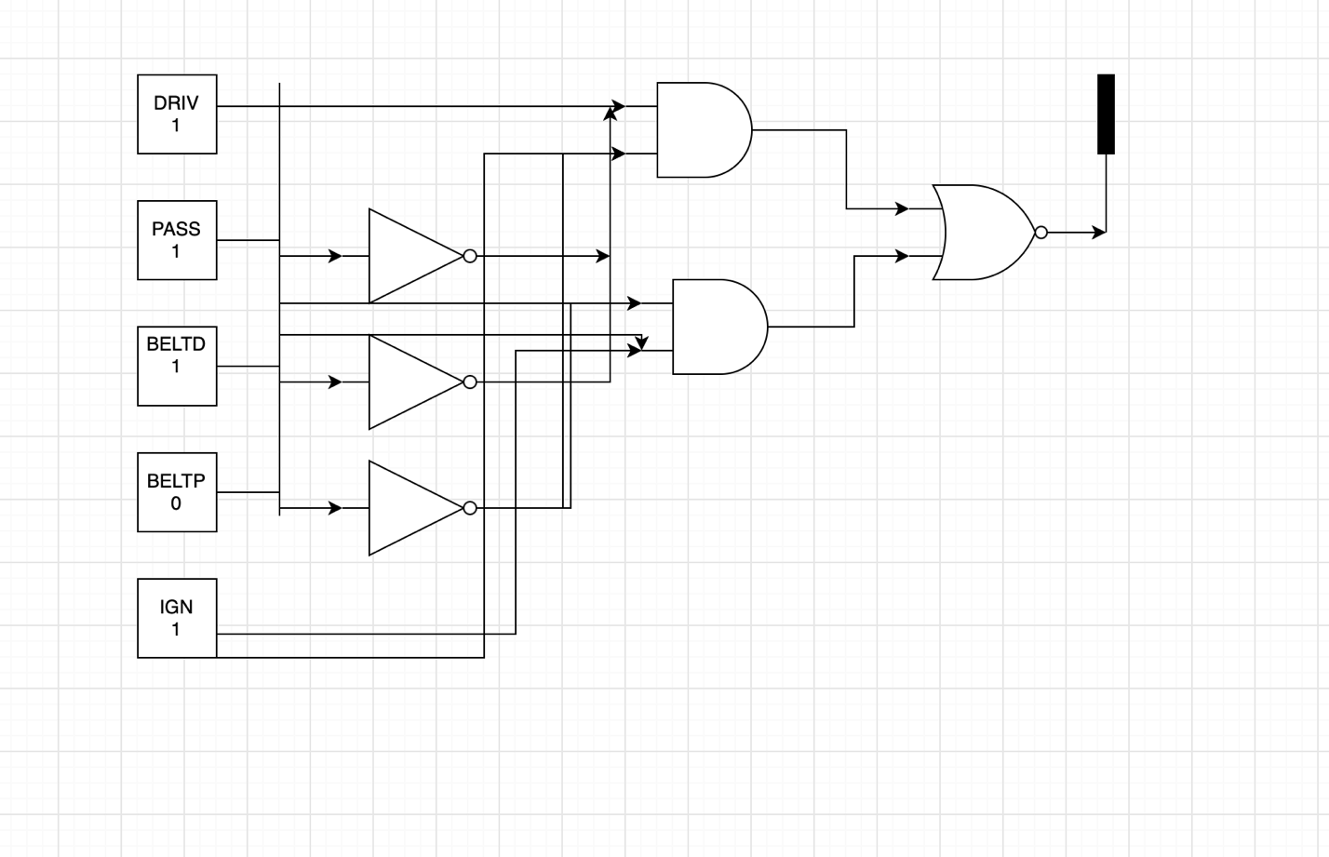

3.5 Pseudocode
START
GET DRIV, PASS, BELTD, BELTP, IGN
IF DRIV. $\overline{PASS}$. $\overline{BELTD}$. $\overline{BELTP}$. IGN + DRIV. $\overline{PASS}$. $\overline{BELTD}$. BELTP. IGN + DRIV. PASS. $\overline{BELTD}$. $\overline{BELTP}$. IGN + DRIV. PASS. $\overline{BELTD}$. BELTP. IGN + DRIV. PASS. BELTD. $\overline{BELTP}$. IGN
THEN
SET ALARM to ON (0)
ELSE
SET ALARM to OFF (1)
END

Step 4: Test and Refine the Solution (Debug and Verify)
Test Data:
DRIV | PASS | BELTD | BELTP | IGN | Expected Output ALARM | Actual Output | Pass/Fail
0 | 1 | 1 | 1 | 1 | 1
1 | 0 | 0 | 0 | 1 | 0
1 | 0 | 0 | 1 | 1 | 0
1 | 0 | 1 | 0 | 1 | 1
1 | 0 | 1 | 1 | 1 | 1
1 | 1 | 0 | 0 | 1 | 0
1 | 1 | 0 | 1 | 1 | 0
1 | 1 | 1 | 0 | 1 | 0
1 | 1 | 1 | 1 | 1 | 1

